## The Game of Life

### General Game Description

A variant of “The Game of Life”.

  
This is a board game where players take turns spinning a spinner and cruise through life.

Along the way they can go to college, pick a career, buy a home and start a family. The objective is accumulating the most money at the end of the game.

The wealthier player wins the game.

### The number of players can range from 2 to 4.

### Game Components

1. The game is composed of the following physical components: Car Pawns, Cards, Money, Spinner, Board. The game also includes a bank which is assumed to hold unlimited money.
2. ***Car Pawns***

The game includes 4 car pawns: pink, blue, green and yellow. Each player should hold a car pawn that will be used to pass or land on the spaces of the board.

Each car pawn also indicates the number of dependents (spouse or children) the player acquires during the game.

***Spinner***

A spinner allows a player to randomly select a number comprised between 1 and 10. Odd numbers are associated with the red color, while even numbers are associated with the black color.

1. ***Cards***
2. The game includes 4 card decks:

* ***Action Cards:*** This deck includes 55 cards.
  + 5 Career change cards: if a player picks this type of card during the game s/he should place his/her Career or College Career card at the bottom of the corresponding deck, pick the top 2 Career or College Career cards on the deck and select the favorite one**.**
  + *10 Players pay cards*: if a player picks this type of card during the game s/he should receive from a player of his/her choice 20K.
  + *20 Pay the bank cards:* if a player picks this type of card during the game s/he should pay the bank the amount of money specified on the card. 4 cards indicate an amount of 10k, 20k, 30K, 40K and 50K.
  + *20 Get Cash from the Bank cards:* f a player picks this type of card during the game the Bank should give the current player the amount of money specified on the card. 4 cards indicate an amount of 10k, 20k, 30K, 40K and 50K.
* ***House Cards*:** This deck includes 14 cards.

Each card has a type, a purchase price, a spin for sale price for odd numbers (indicated in red in Fig. 1), and a spin for sale price for even numbers (indicated in black in Fig. 1).

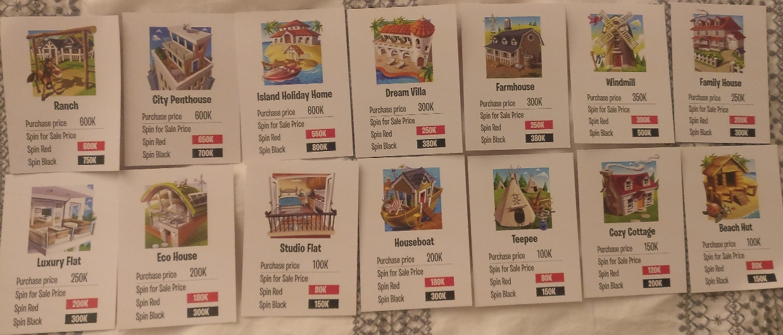

Figure 1. House Cards

* ***Career Cards:*** This deck includes 8 cards***.***

As indicated in Fig. 2 each card has a career type and a bonus number. When any player spins the spinner, the player holding the career card with the same bonus number indicated by the spinner should receive 20K from the bank.

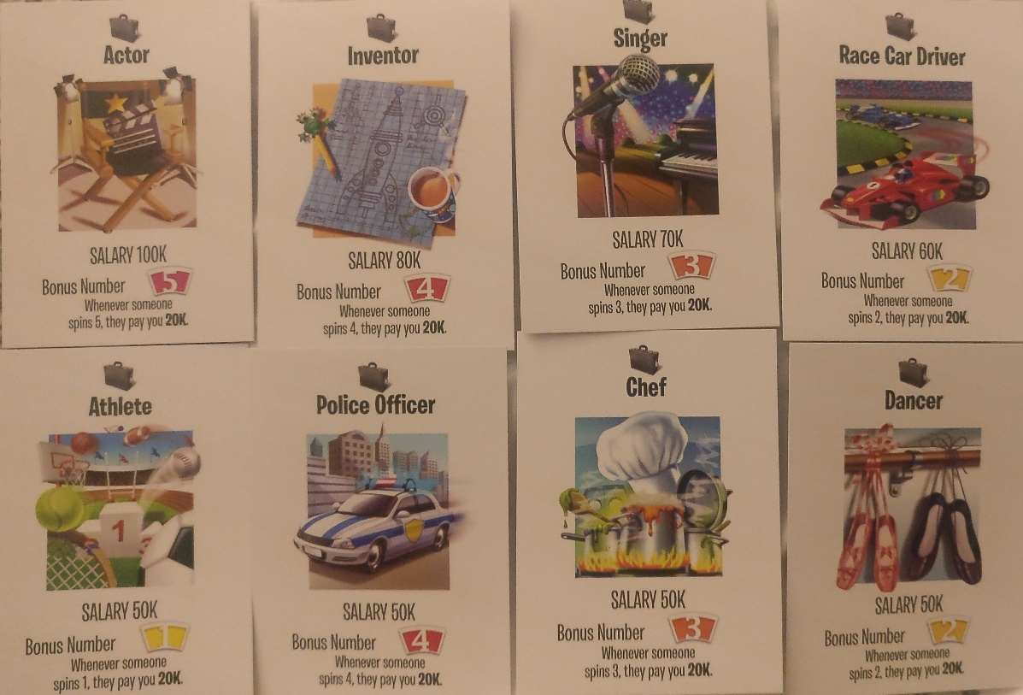

Figure 2. Career Cards

* ***College Career Cards:*** This deck includes 12 cards

As indicated in Fig. 3 each card has a career type and a bonus number. When any player spins the spinner, the player holding the career card with the same bonus number indicated by the spinner should receive 20K from the bank.



Figure 3. College Career Cards.

***Board***

It is characterized by a sequence of adjacent spaces. The board has two start spaces (*Career Path* and *College Path*) and an end space (*Retirement*). Note that each space can have 1 or 2 subsequent spaces. An example of the board is indicated in Fig.4.

### Game Set-Up

At the beginning of the game each player should select a car pawn that has not been selected by any other players and should receive 200K.

All the card decks should be initialized and shuffled separately.

The board should be initialized with a set of space.

Each player has to choose a career path:

* *College Career Path:* The player will be more likely to get a better paying job. However s/he should pay the bank 100K immediately.
* *Career Path:* The player will be more likely to get paid sooner. The player should take 2 top career cards from the deck and choose his/her favorite and place the other one at the bottom of the deck.

The car pawn of the player should be placed on the career path space or the college career path space depending on the initial choice made by the player.

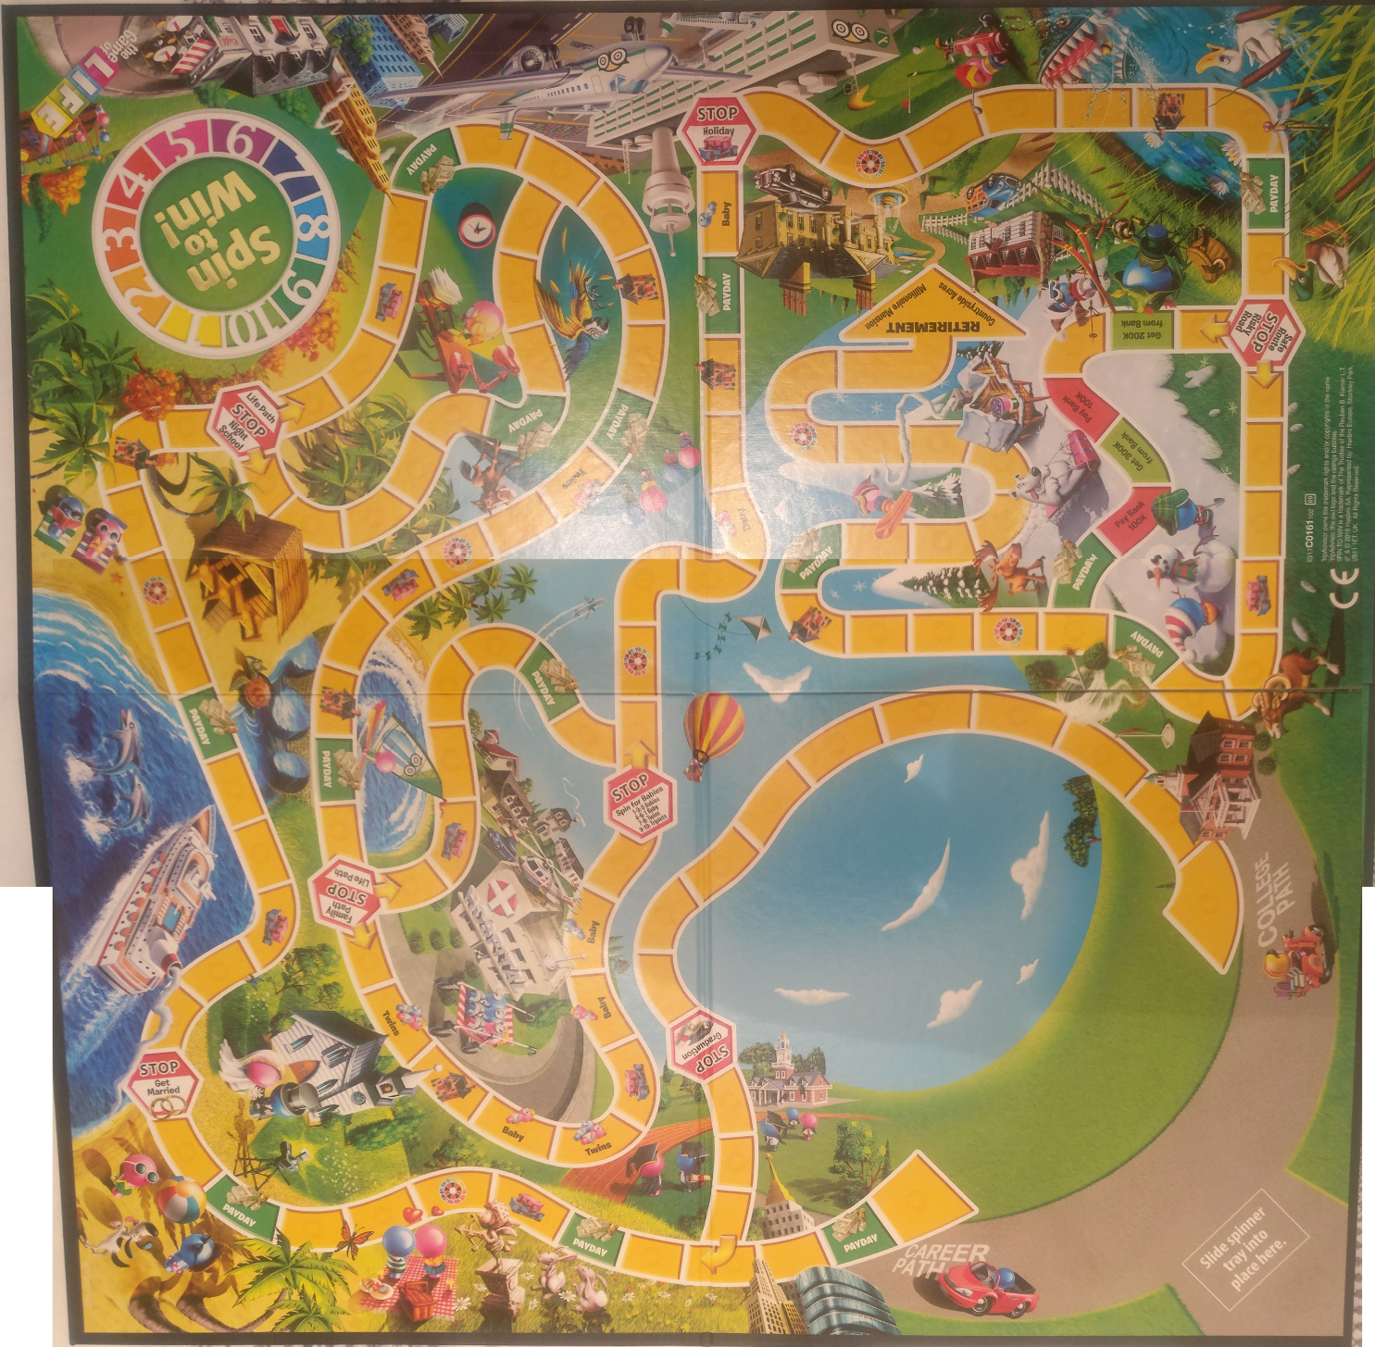

Figure 4. The Board.

### Game Turns

* Each player in turn should spin the spinner and move his/her car pawn of a number of spaces equal to the number indicated by the spinner. Movements should take place along the career path one chooses. Car pawns should not move backwards.
* Depending on the spaces a car pawn passes or lands on, different actions will have to be performed as indicated below:

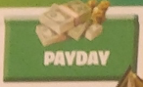***Payday Spaces*:**

* If a car pawn *passes* a Payday space, the corresponding player should collect the salary indicated in his/her Career or College Career Card from the Bank.
* If a car pawn *lands on* a Payday space, the corresponding player should collect the salary indicated in his/her Career or College Career Card from the Bank and also take an additional 100K bonus.

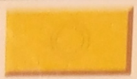***Action Spaces*:**

If a car pawn lands on an action space, the corresponding player should select the top *Action* *card* from the deck and do what it says. The player should maintain the action card until the end of the game.

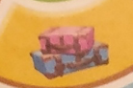

***Holiday Spaces*:**

When a car pawn lands on this space, nothing should be done.

***Spin to Win Spaces:***

When a car pawn lands on this space, the current player should choose 2 different numbers from 1 to 10.

* All the other players should choose a different number from 1 to 10 following the turns order.
* Then the current player should spin the spinner until one of the numbers selected by one of the players comes up. In that case the player who has selected the number indicated by the spinner should receive 200K from the Bank.

***Baby Spaces***

When a car pawn lands on this space it means that the current player had a baby. The car pawn should update the number of the player’s children incrementing it by how many babies the space indicates.

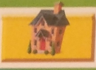

***House Spaces***

When a car pawn lands on this space, the current player should choose to buy a house, sell a house or do nothing.

* *To buy a house*: The player should pick and view the top 2 House cards from the deck. Then the player should choose his/her favorite card and pay the Bank the purchase price. The other House card should be returned to the deck.
* *To sell a house*: The player should spin the spinner. If the spinner ends up on an even number the player should collect from the bank the sale price associated with the black color on the House card. If the spinner ends up on an odd number the player should collect from the bank the sale price associated with the red color on the House card. The House card is subsequently returned to the deck.

***Stop Spaces****:* When a car pawn passes a stop space it should stop on that space even if it has more moves left. There are different types of stop spaces.

Graduation *Stop:* The current player should take the top 2 College Career cards from the deck. S/he should choose his/her favorite card and keep it because that will represent his/her job. The other card should be placed at the bottom of the deck.



Get Married Stop:The status of the car pawn should be updated to indicate that the player has a spouse. Each of the other players should spin the spinner. If the spinner ends up on an odd number, the player spinning the spinner has to give the married player 100K, 50K otherwise. Finally the married player should spin the spinner to move again.

*Night School Stop:* The player can decide to keep his/her job or change career. If the player decides to change career, s/he should give the bank 100K, take the top college career card on the deck and place the current career/college career card at the bottom of the deck. In any of these cases the player will have to move his/her car pawn again using the spinner.



Family Stop: The player should decide whether to move towards the family path (i.e. having kids) or towards the life path (i.e. not having kids).

**

*Baby Stop:* The player should spin the spinner to see how many babies s/he had. 1-3 on the spinner corresponds to zero kids. 4-6 on the spinner corresponds to 1 kid. 7-8 on the spinner corresponds to 2 kids. 9-10 on the spinner corresponds to 3 kids.

**

*Holiday Stop:* the current player should do nothing.

The game should not include the risky stop and the risky path indicated in Fig. 4.

In the event a player runs out of money s/he has to ask for a bank loan. The player will have to decide how many loans s/he will have with the bank; for each loan the player should receive 50K.

### Game Termination

### When the car pawn of a player reaches the retirement space, a player can retire.

### In that case s/he should receive an extra amount of money from the bank depending on whether s/he is the 1st (400K), 2nd (300K), 3rd (200K), or 4th (100K) player to retire. The retiring player should also repay the bank 60K for each loan s/he had.

When all the players retire, they should

* sell all their houses by applying the same procedure explained in the House spaces;
* collect 100K from the bank for each action card they hold;
* collect 50K from the bank for each children they have.

After each player retires the wealthiest player should be identified (i.e. the one who has more money). That is considered the winner.